Ex. No. 4 | COPYING OF DATA FROM BROWSER TO NOTEPAD
Date of Exercise | 22/01/2026

AIM
To automate notepad application and copying data from browser to notepad using UiPath.
DESCRIPTION
This experiment demonstrates automating the Notepad application using UiPath by copying text from a browser. UiPath Studio is used to open a browser, extract selected text from a web page, and store it in a variable. The extracted text is then typed into the Notepad application automatically. This shows how UiPath can integrate multiple applications to automate data transfer efficiently.
PROCEDURE:
Step 1: Open UiPath studio and click process to start a new project.
Step 2: Create a new blank process by giving a name and give create.
Step 3: Click Open main workflow.
Step 4: Open any website in the browser.
Step 5: From the activates choose - use browser/application option. And indicate the browser window in it.
Step 6: Create a variable for the browser and for variable type search UiPath.core.browser .
Step 7: From the activities chose Get text. Create a variable Textout and chose scope as sequence. Click on Get text to get the properties on the right corner. In the output text type as Textout. Click indicate element inside browser and chose the text which you prefer to type in notepad.
Step 8: Open notepad application. From the activities chose use browser/application and using insert element inside browser insert the notepad image.
Step 9: From the activities Chose Type into using insert element inside browser click image of notepad where you want the text to type in. Type textout. Save file close notepad and run it.
Step 10: We got the text selected in browser on notepad.
OUTPUT:
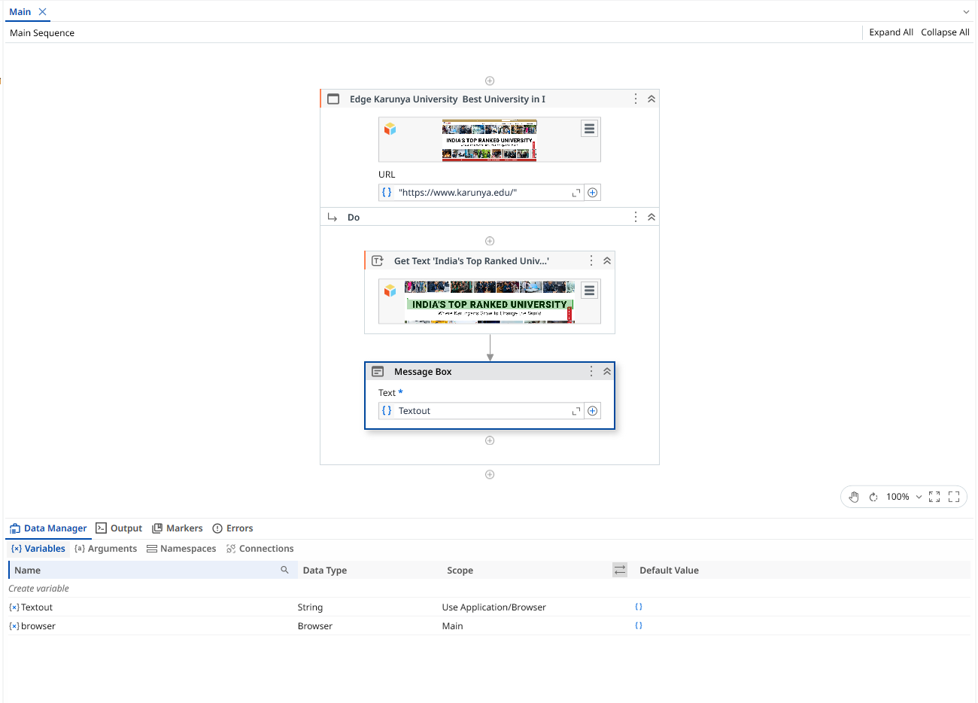


Result
Thus, the copying of data from browser to notepad is completed successfully.

